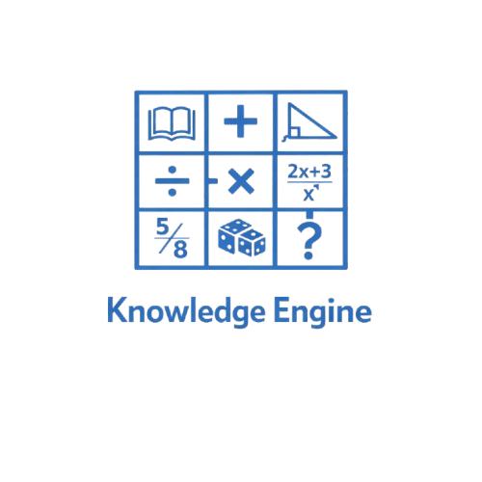

Contents
Assignment 3
Our Team: Knowledge Engine 4
Stages of development 5
Project description 6

Assignment

The topic is “Digital School” Our task was to create a C++ to make learning math easier in 2025/2026 school year. The project had to follow specific requirements: clear code structure, clear variables, optional use of external libraries, and an active GitHub repository showing commits, task planning, and collaboration.
We worked in a team of four, each with a defined role such as Scrum Trainer, Front-End Developer, Back-End Developer, or Designer. Everyone contributed to the development of the final product.
The project duration was from 28.02.2026 to 25.03.2026. During this time, we built the program, organized the project files, prepared documentation, and created a presentation. Each member also described their technical work in the documentation.
This project reflects our teamwork, coding abilities, and understanding of how to build and document a complete C++ program.

Our Team: Knowledge Engine

№ | Name and class | Role
№1 | Martin Zhelev - 9V | Scrum trainer
№2 | Dimitar Nyagalov – 9B | Designer
№3 | Georgi Nikolov – 9A | Back-End Developer
№4 | Ivan Trifanov – 9A | Back-End Developer

Number of Possible Test Variants
The Knowledge Engine test is generated randomly using only four operations:
- Addition
- Subtraction
- Multiplication
- Division
Each question is created using:
\mathrm{number1}; \mathrm{operation}; \mathrm{number2}
If the program uses numbers from 1 to 20, then:
- 20 possible values for number1
- 20 possible values for number2
- 4 operations
So, the number of unique questions is:
20\times 20\times 4=1600

Total Number of Test Variants:
If the test contains 20 questions, and each question is chosen independently from the 1,600 possible questions, then:
1600^ {20}
This is an extremely large number:
≈ 1.46 × 10⁶⁰ possible test variants

Result:
The program can generate over 10⁶⁰ unique tests,
making every test effectively unique.

Stages of development

№ | Stage
1 | Planning  Choosing the topic, forming the team, assigning roles.
2 | Design  Structuring the program for math problems
3 | Implementation  Writing the C++ code and building all game features.
4 | Collaboration  Using GitHub for commits, tasks, and version control.
5 | Finalization  Finishing documentation, presentation, and publishing the project.

Project description
This project is a C++ console application developed for the theme “Math Learning and Testing.” The goal was to create a program where users can study mathematical topics and then test their knowledge through an automatically generated exam. The system provides structured information on key math concepts, followed by a test module that allows learners to apply what they have studied and evaluate their understanding.
Our team collaborated using modern tools to plan, build, and document the project. Development was carried out in Visual Studio, with version control and teamwork managed through Git and GitHub. Documentation and presentation materials were created using Microsoft Word and PowerPoint, while communication, coordination, and task distribution were handled through Microsoft Teams.
The project follows a clear and organized code structure, with separate modules for the learning content, test generation, scoring, and shared data types. This modular approach improves readability, simplifies debugging, and supports efficient teamwork across different roles. The result meets all assignment requirements and represents a complete, well‑structured, and collaborative team effort.

